Needed items

two main job category’s and pictures

1 sentence on each one

2 paragraphs on business

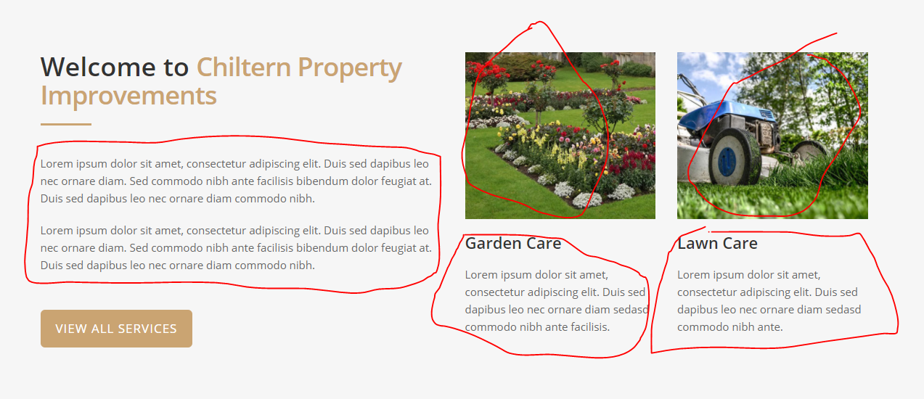

Home and Garden Improvments service list

Diy Services Service List

Fitted Wardrobes Description and picture

Bespoke work Description

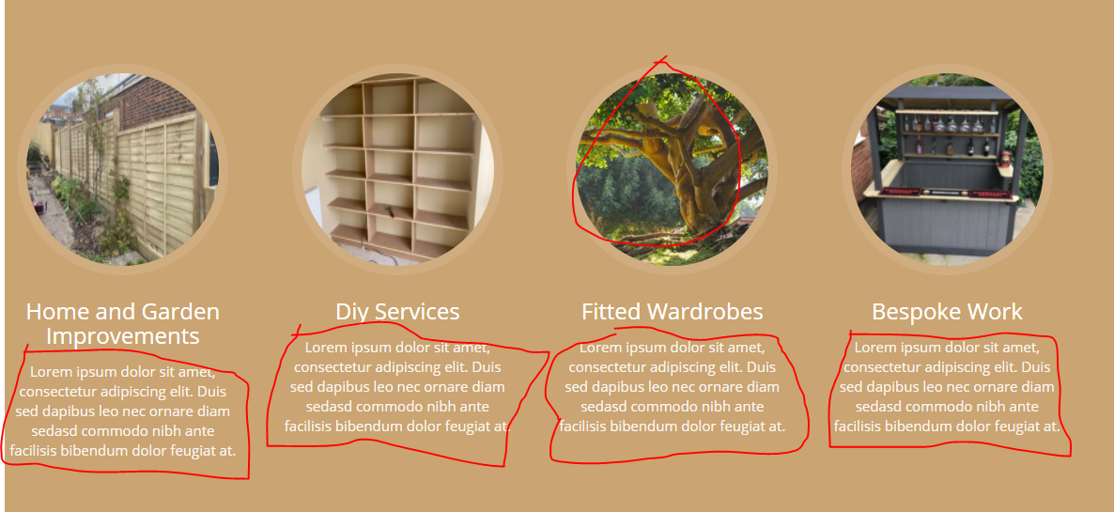

Testimonials – needed

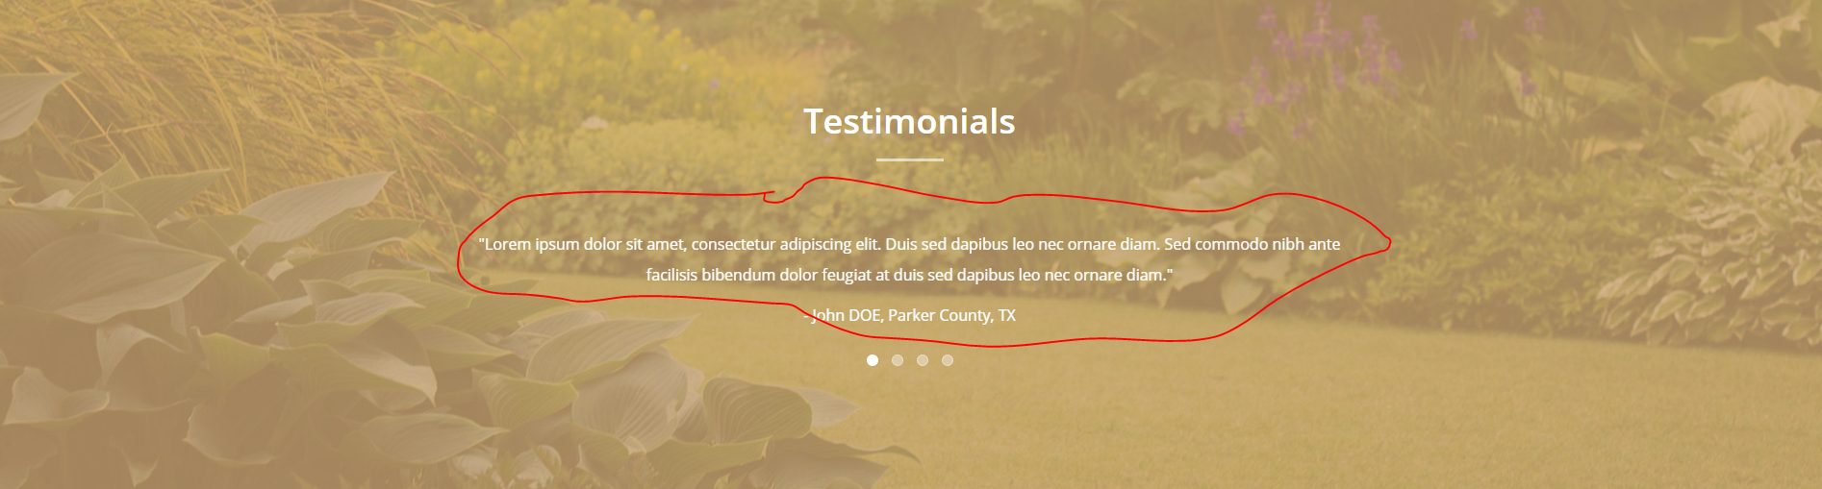

Address needed and second phone number

